​So far, you've used Initialize Agent to set up agents with predefined strategies such ​as React or Structured Chat. ​Now, let's look at another way to build agents with even more flexibility, LangGraph, ​which is quickly becoming the preferred approach over Initialize_Agent for building ​robust, multi-step agent workflows.
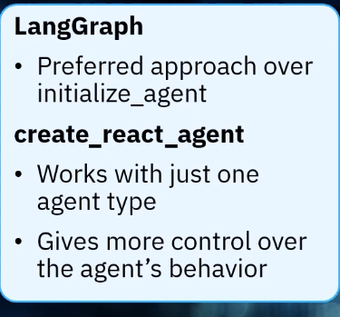
To create a React-style agent in LangGraph, use the "create react agent" function from the ​langgraph.prebuilt module. ​Create the agent using the "create react agent" and pass in the LLM and a list of tools, for ​example, sum numbers with complex output. ​Optionally, include a custom prompt to guide the agent's behavior. ​
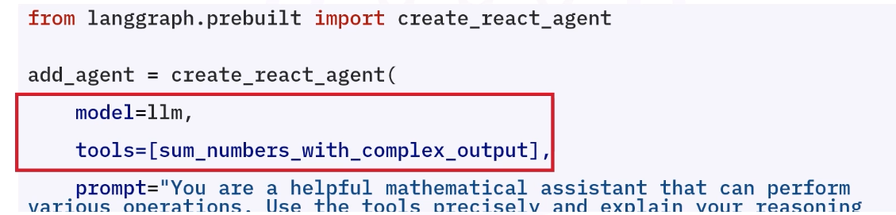
https://chatgpt.com/c/69f5e5c5-5f00-83e8-823e-948212c074c1 (in order to know why we pass a dict in invoke)
Then use the .invoke() method:
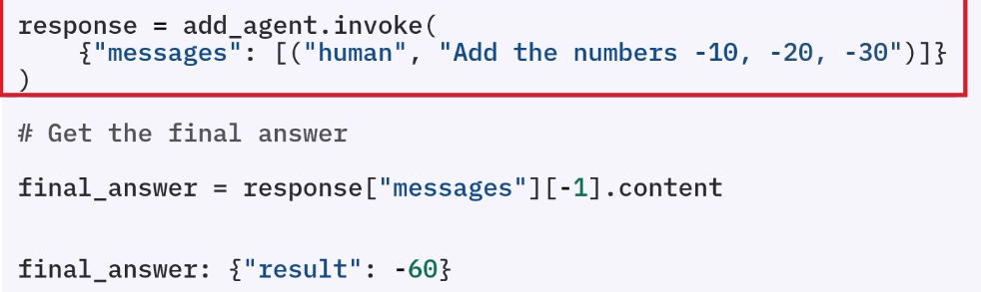
This is how LangGraph / modern agents work
👉 They expect a chat-like input format
- response["messages"] → list of all messages
- [-1] → last message (final output)
- .content → actual text

Lets now take an example and build an agent to handle banking transactions (withdrawal, transfer and deposits). We will build a simple math toolkit. It will have addition tool, multiplication, division and subtraction tool.
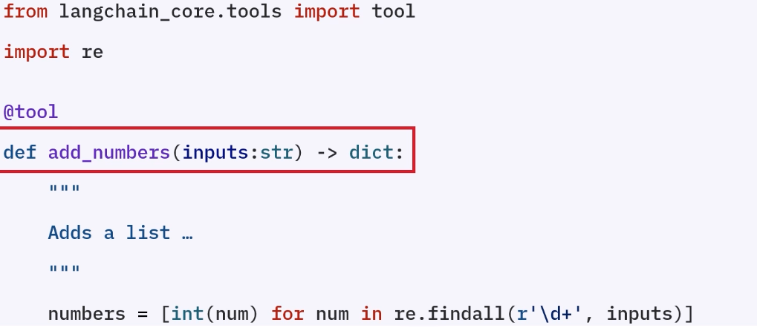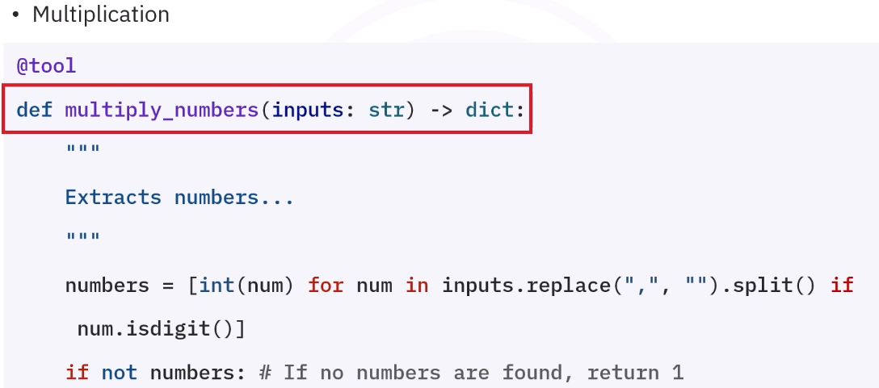
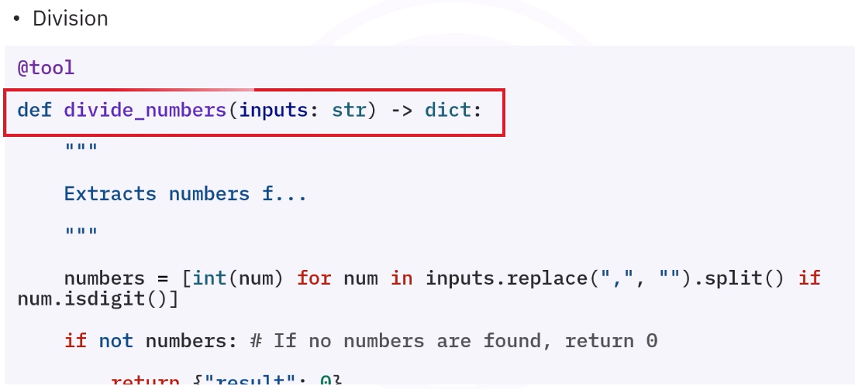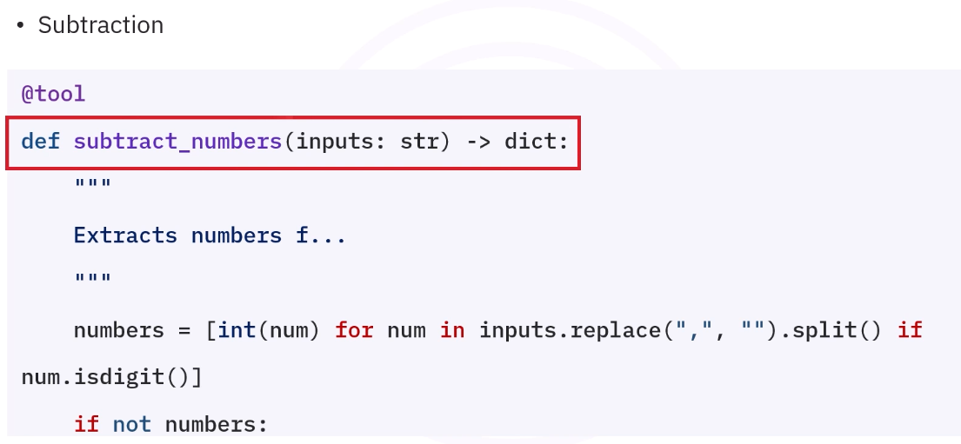
Now that toolkit is ready, we create agent using create_react_agent().. langgraph.
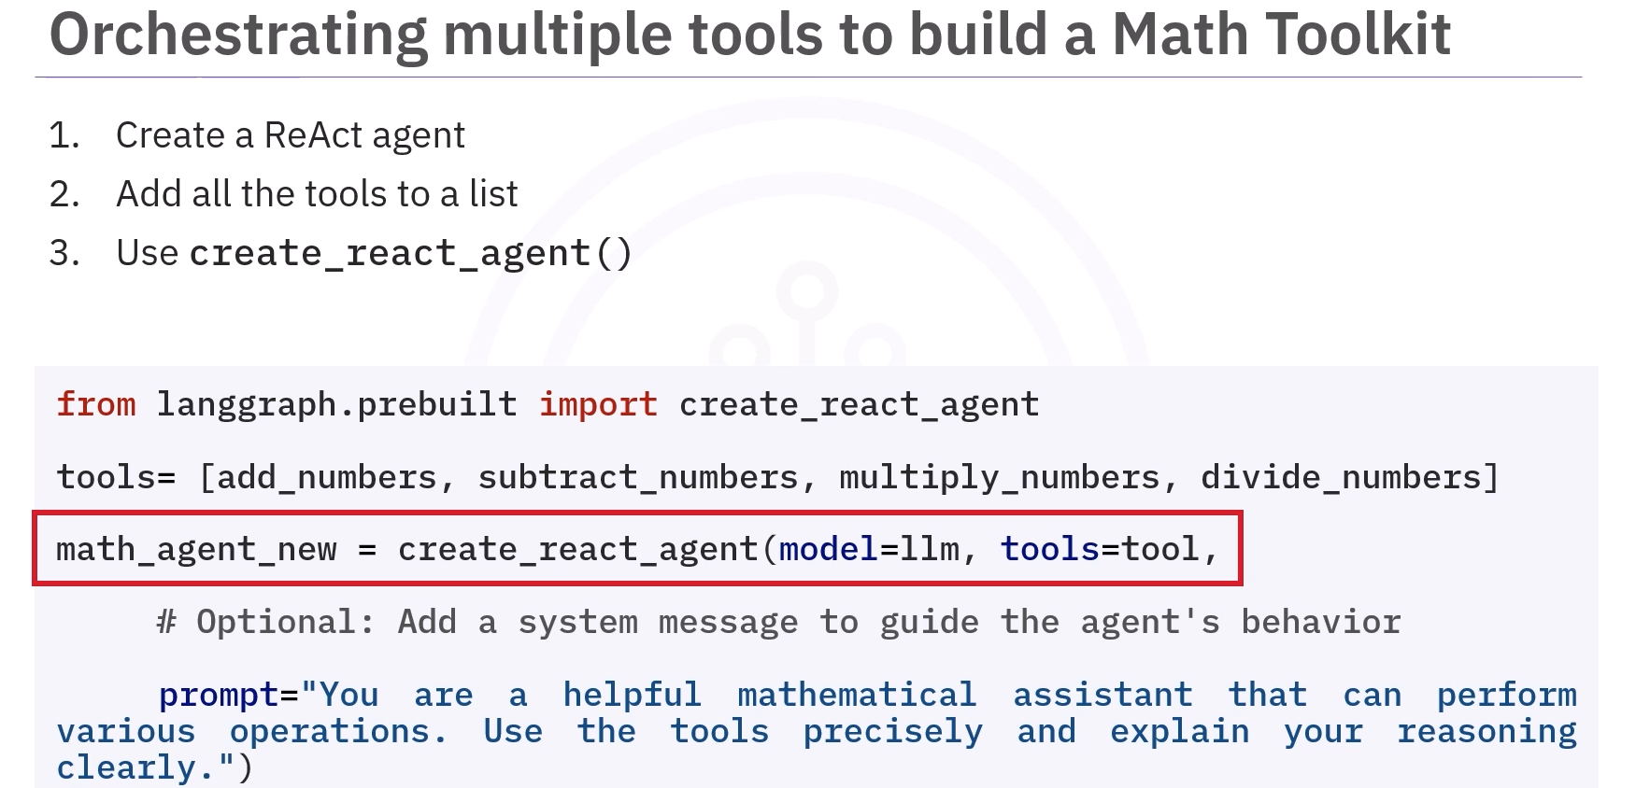
https://chatgpt.com/c/69f6346a-637c-83e8-a4cd-345fcc5af790
Then invoke the agent
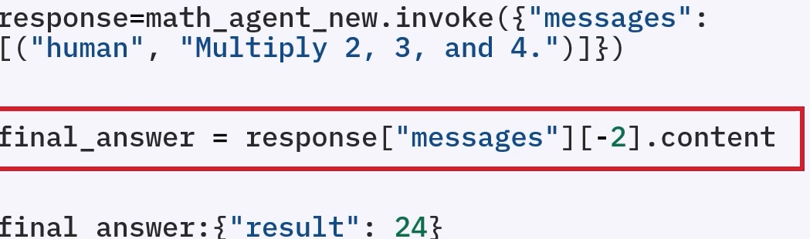
while invoking the agent, in final answer how come we know to query [-2] and what is ["messages"]
This is a very sharp observation — this is exactly where most people get confused. Let’s clear it properly 👇

🔹 First: What is response["messages"]?
When you do:
response = agent.invoke(...)
👉 You don’t just get the answer
👉 You get a list of all messages exchanged during reasoning

🔹 Structure looks like this:
response = {
"messages": [
HumanMessage(...), # user input
AIMessage(...), # thought / tool call
ToolMessage(...), # tool output
AIMessage(...), # final answer
]
}

🔥 So:
response["messages"]
👉 = entire conversation history

🔹 Now the important part: indexing
Python indexing refresher:
Index | Meaning
[0] | first item
[-1] | last item
[-2] | second last

🔹 Why sometimes [-1] works and sometimes [-2]?
👉 Because the last message is not always the final answer

🔥 Case 1 (your earlier example)
final_answer = response["messages"][-1].content
👉 Works when:
- Last message = final AI answer

🔥 Case 2 (this screenshot)
final_answer = response["messages"][-2].content
👉 Why -2?
Because structure is like:
[
HumanMessage("Multiply 2, 3, 4"),
AIMessage(tool_call), # "I will use multiply tool"
ToolMessage("24"), # tool output
AIMessage(final_answer) # sometimes empty / formatted differently
]
👉 In some LangGraph flows:
- Last message may be wrapper / metadata
- Actual result is in second last message

🔹 So how do we KNOW?
👉 Answer: We don’t “guess” — we inspect

🔥 Best practice
Always do:
print(response["messages"])
👉 Then see:
- Which message contains actual answer
- Whether it's [-1] or [-2]

